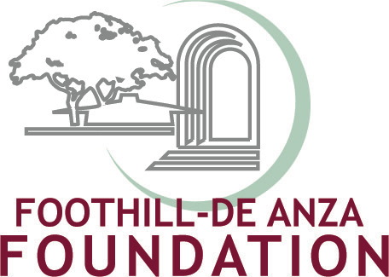

THE FOOTHILL-DE ANZA COMMUNITY COLLEGE DISTRICT
FAST FACTS

Did you know?

- Our community college district serves about 44,000 students who enroll each fall. About 24,000 at De Anza and 20,000 at Foothill.

- FHDA employs more than 2,400 people, and is the 20th largest employer in Silicon Valley, on a par with Adobe Systems and Electronic Arts Inc.

- The Foothill-De Anza Community College District directly and indirectly contributes more than $800 million to the local economy each year.

- More than one million students have been educated since the District’s founding in 1957.

- Of 15,289 Santa Clara County public high school graduates in June 2006
  - 15 percent enrolled at Foothill or De Anza the following fall
  - 14.6 percent enrolled at UC campuses
  - 13.4 percent enrolled at CSU campuses

- Foothill and De Anza are among the top districts in the state in transferring students to universities—in fact number one in transfers to UC’s.

- In 2006-2007 De Anza College awarded:
  - 1,075 associate degrees
  - 623 certificates
  - 575 transfers to UC
  - 1,251 transfers to CSI

- In 2006-2007 Foothill College awarded:
  - 523 associate degrees
  - 728 certificates
  - 268 transfers to UC
  - 420 transfers to CSU

Did you know?

- About 75 percent of our first-time freshmen have not mastered basic skills in math or language arts, consistent with state and national trends. Foothill-De Anza is a leader in helping academically under-prepared students develop the skills they need to succeed in college.

- Studies show that every year of community college instruction increases earnings by 5-6 percent at any point in a person’s career. Students who earn associate degrees average lifetime earnings of $250,000 more than people without degrees.

- Since it opened in 2000, the Krause Center for Innovation at Foothill College has trained more than 11,000 local elementary, middle and high school teachers to use the latest technology in the classroom to increase student success, serving more than 25 local K-12 school districts.

- Innovative ideas by faculty and staff attracted more than $4.7 million in grants to Foothill-De Anza in 2006-07 to supplement state funding. Grants help us provide extra services for students. For example, a $2 million federal grant announced in June will underwrite “success centers’’ at De Anza College to help academically under-prepared students transition to college-level work at higher rates.

- The Foothill-De Anza Foundation is one of the most successful community college foundations in the state, raising more than $5 million in 2007 in support of students and programs, and with nearly $30 million in net assets.

- The Foothill-De Anza Foundation Board, the Foothill Commission and the De Anza Commission are all comprised of philanthropic community leaders who seek to fill the growing financial gap created by diminishing state funding.

- Foothill-De Anza scored in the state’s top tier on the first Accountability Report of California Community Colleges (ARCC). The report showed that both colleges had high course completion, achievement, progress, and persistence rates.

- Foothill astronomy professor Andrew Fraknoi, enjoyed by generations of community college students, has been named the 2007 California Professor of the Year by the Carnegie Foundation for the Advancement of Teaching and the Council for Advancement & Support of Education (CASE).

- De Anza College won accolades for its teaching and support of students in a national study on excellence in higher education, called the Project on Good Works, conducted by respected Stanford, Claremont Graduate and Harvard University professors.
Did you know?

- Foothill-De Anza maintains budget reserves of at least 5 percent, above the minimum audit requirements for the California Community Colleges.

- Foothill-De Anza’s Board of Trustees adopted a plan to fully fund its $155 million retiree medical benefits liability incurred prior to 1997. The annual contributions are placed in an irrevocable trust.

- An independent Citizens’ Bond Oversight Committee was formed to review spending and report to the community annually on the district’s $490.8 million Measure C bond program, which was approved by voters in June 2006. For maximum transparency, the committee has launched a Measure C bond web site, www.MeasureC.fhda.edu.

- The Measure C bond program is subject to annual independent financial and performance audits.

- Foothill-De Anza has one of the highest bond ratings in the state, “Aa1’’ from Moody’s Investors Service and “AA” from Standard & Poors.

- The district’s Board of Trustees adopted a new Facilities Master Plan that will guide renovations and new construction over the next decade. The building plan is based on objectives in the district’s Educational Master Plan (http://www.fhda.edu/about_us/).

- Energy-saving projects recently completed at both campuses are expected to lower power costs by 30-50 percent, resulting in savings of more than $800,000 annually.

